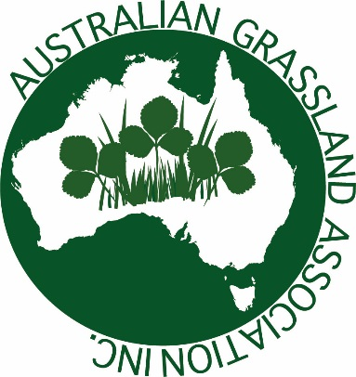

Guidelines for preparing papers for the Australian Grasslands Association

Important points for paper preparation and submission

- All papers MUST be prepared using the required formats and style.

- Submission and acceptance of a paper implies a commitment by you to present your paper at the symposium and to prepare a full paper to the required standard for publication in Crop and Pasture Science. Paper submission to Crop and Pasture Science will require meeting strict deadlines.

- Submission and acceptance of a poster paper for publication in the proceedings implies a commitment that at least one of the authors will be attending the symposium and that a poster will be prepared for display at the symposium.

- ALL deadlines specified by the Organising Committee must be strictly adhered to. While for many authors submission of a paper is their final major input, there are a range of processes that must occur in order for the printed proceedings to be available at the symposium and for publication of the special edition of Crop and Pasture Science. These are all time dependent and include collation and review, editing, proof reading, formatting and layout, and printing and distribution. Late submissions and poorly prepared papers add considerably to time delays and frustration for those involved in these processes.

Abstract guidelines

- The title should be brief but specific to the subject of your paper.
- Abstracts are required for all papers, and must not exceed 250 words. The Abstract should be a précis of the context, aim, approach and findings; i.e. an accurate summary of the information to be presented in the paper.
- Authors’ names and addresses should be shown below the Abstract title, as specified under Author’s names and Author’s addresses below and in the sample paper template.
- A sample Title and Abstract is shown on the following page.
- Email abstracts to: bcullen@unimelb.edu.au

Guidelines for publication in the special issue of Crop and Pasture Science

- Selected papers will be invited to submit their paper to a special issue of Crop and Pasture Science.
- Strict timelines will be provided by the conference organising committee and must be adhered to.
- Manuscripts should be prepared according to the Crop and Pasture Science Author guidelines: http://www.publish.csiro.au/cp/forauthors/AuthorInstructions

Sample abstract: a standard template for preparing Abstracts for the Australian Grasslands Association

R.W. Jones^{A}, J.B. Smith^{B} and C.D. Wesson^{C}

^{A}Regional Agricultural Institute, Woobygong NSW 2500: rjones@regional.gov.au
^{B}Air and Water Services, Weewee Research Station, Woopwoop, Vic 3999: john.smith@water.oz.au ^{C}Revolving Door Research Institute, Whybother, NSW 2900; col.wesson@smokingun.org.au

Abstract: The abstract should contain a summary of the context and aim of the paper, the information to be presented and the key conclusions. Maximum word number for the Abstract is 250 words.

